

**VIVEKANANDA INSTITUTE OF PROFESSIONAL STUDIES - TECHNICAL CAMPUS**

# Grade A++ Accredited Institution by NAAC

NBA Accredited for MCA Programme; Recognized under Section 2(f) by UGC;

Affiliated to GGSIP University, Delhi; Recognized by Bar Council of India and AICTE An ISO 9001:2015 Certified Institution

# SCHOOL OF ENGINEERING & TECHNOLOGY

**B.Tech Programme: Computer Science & Engineering**

**Course Title: Data Warehousing Data Mining Lab**

**Course Code: CIE-425P**

**Semester: 7  th**

**Submitted To: Submitted By:**

**Dr. Shalini Gamhir Name: Arihant Jain**

**Enrollment No: 03417702722**

**Branch & Section: CSE-A (G2)**



An ISO 9001:2015 Certified Institution

**SCHOOL OF ENGINEERING & TECHNOLOGY**

**VIVEKANANDA INSTITUTE OF PROFESSIONAL STUDIES - TECHNICAL CAMPUS**

**Grade A++ Accredited Institution by NAAC**

NBA Accredited for MCA Programme; Recognized under Section 2(f) by UGC;

Affiliated to GGSIP University, Delhi; Recognized by Bar Council of India and AICTE

## VISION OF INSTITUTE

To be an educational institute that empowers the field of engineering to build a sustainable future by providing quality education with innovative practices that supports people, planet and profit.

## MISSION OF INSTITUTE

To groom the future engineers by providing value-based education and awakening students' curiosity, nurturing creativity and building capabilities to enable them to make significant contributions to the world.

## EXPERIMENT 1

**Aim:**  Study of ETL process and its tools.

**Theory:**

**Dataset:**

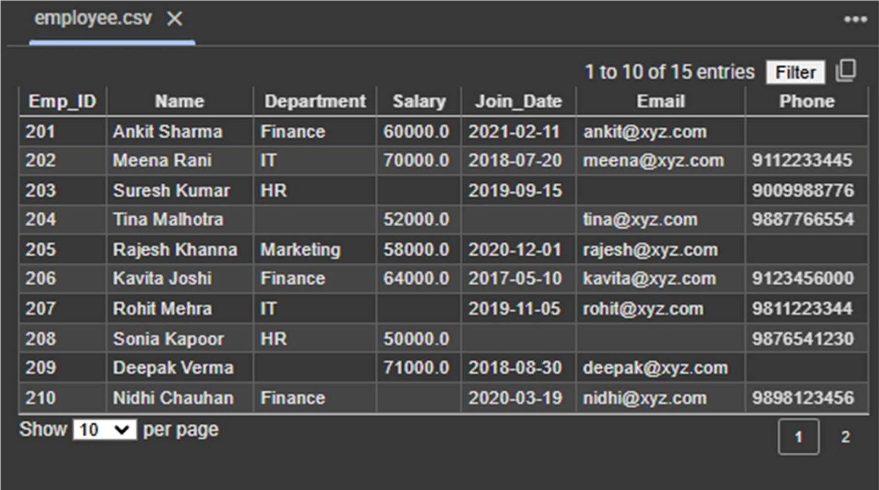

**Program:**

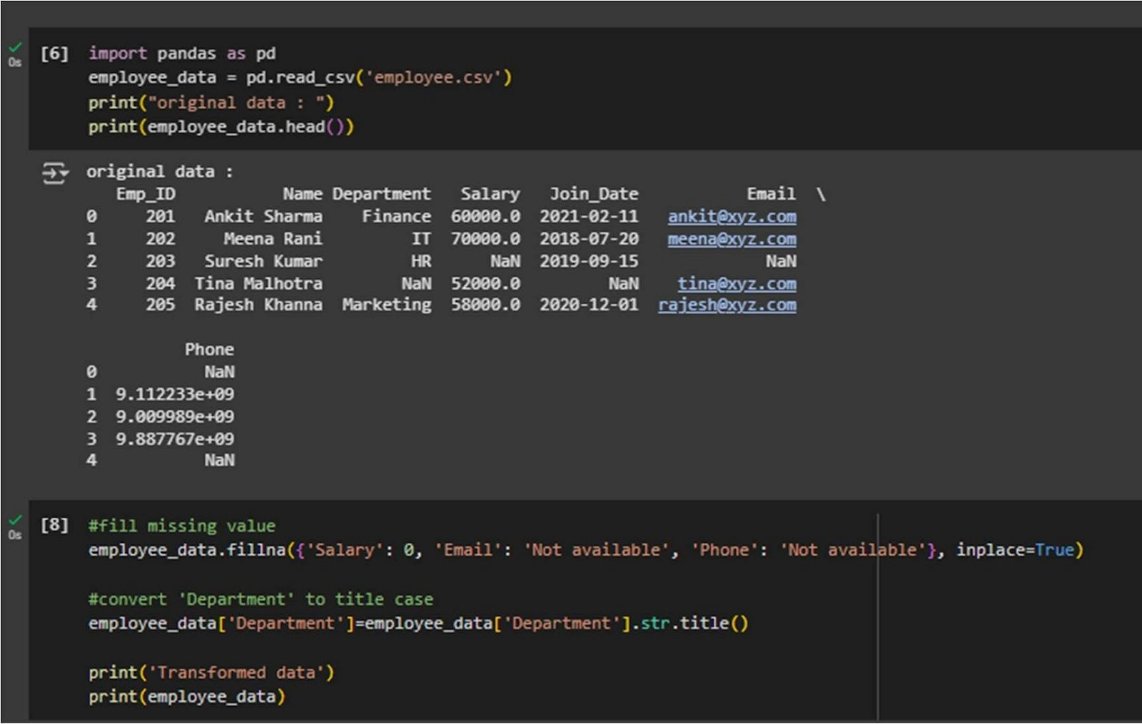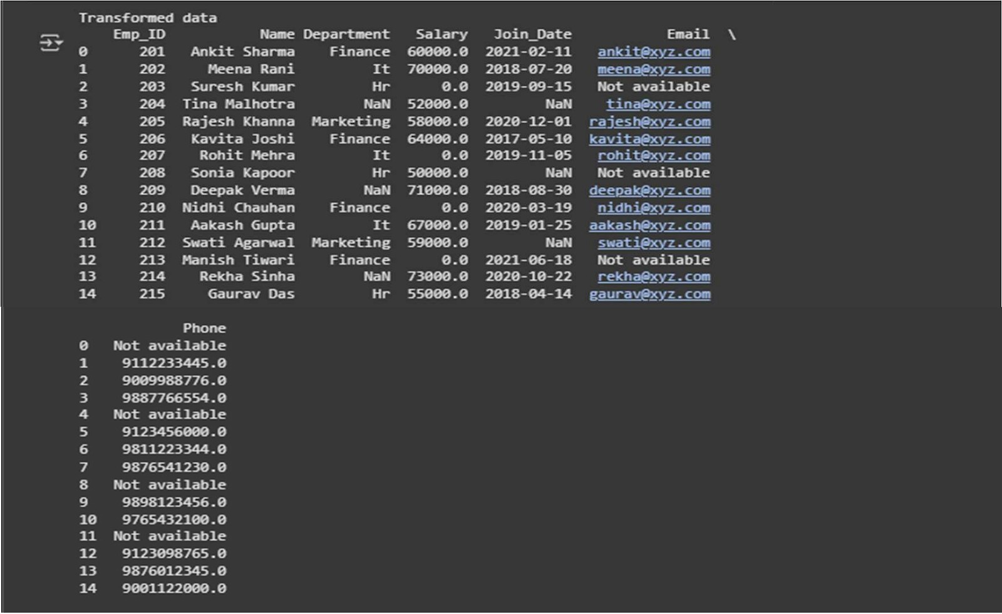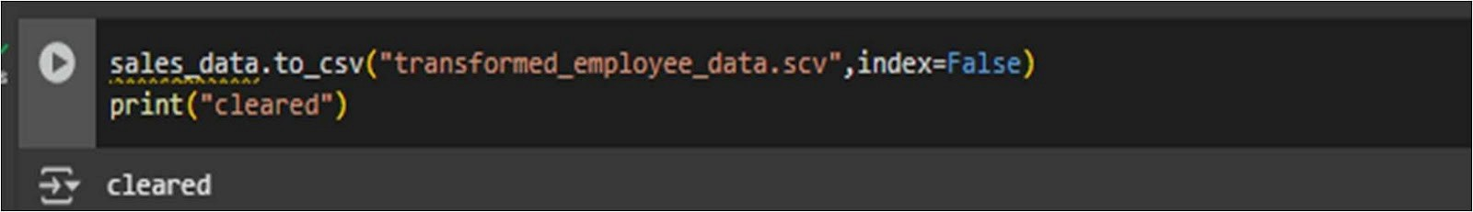

**Output:**

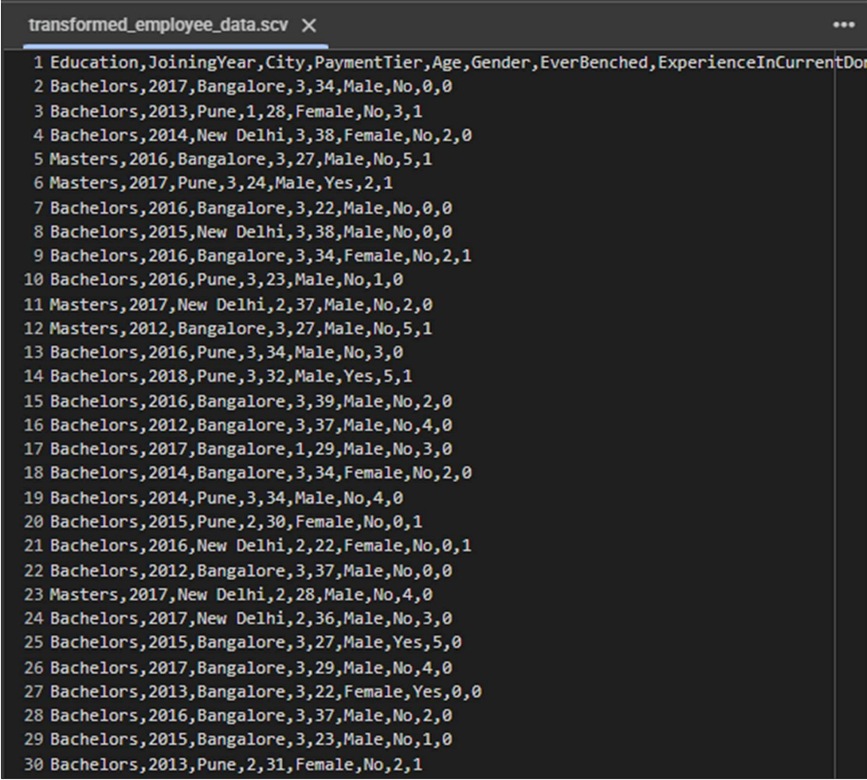

**Learning Outcomes:**

## EXPERIMENT 2

**Aim:**  Program of Data warehouse cleansing to input names from users (inconsistent) and format them.

**Theory:**

**Dataset:**

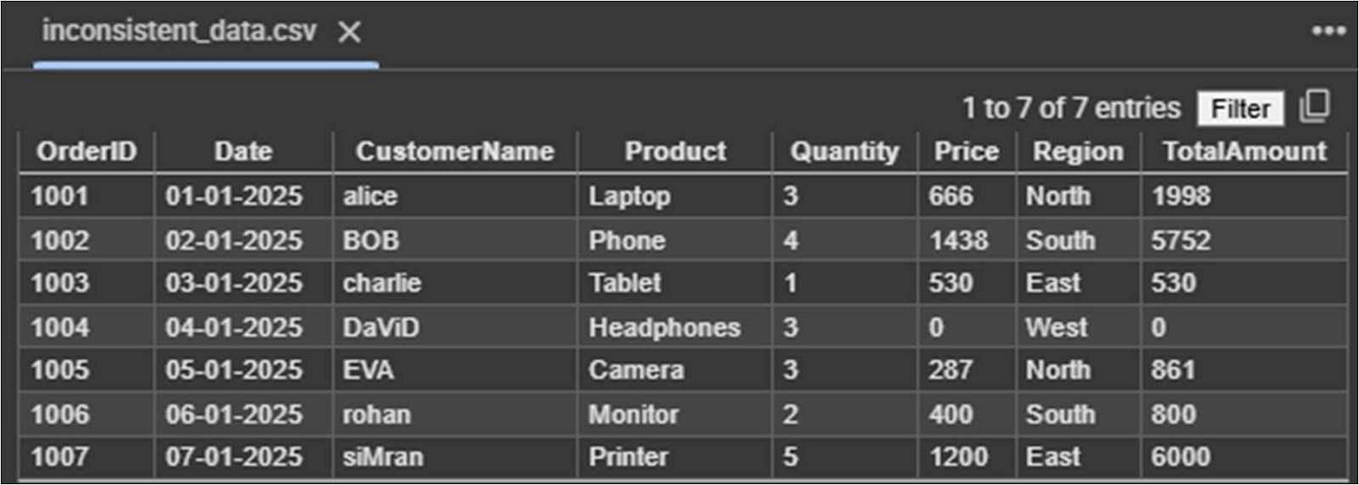

**Program:**

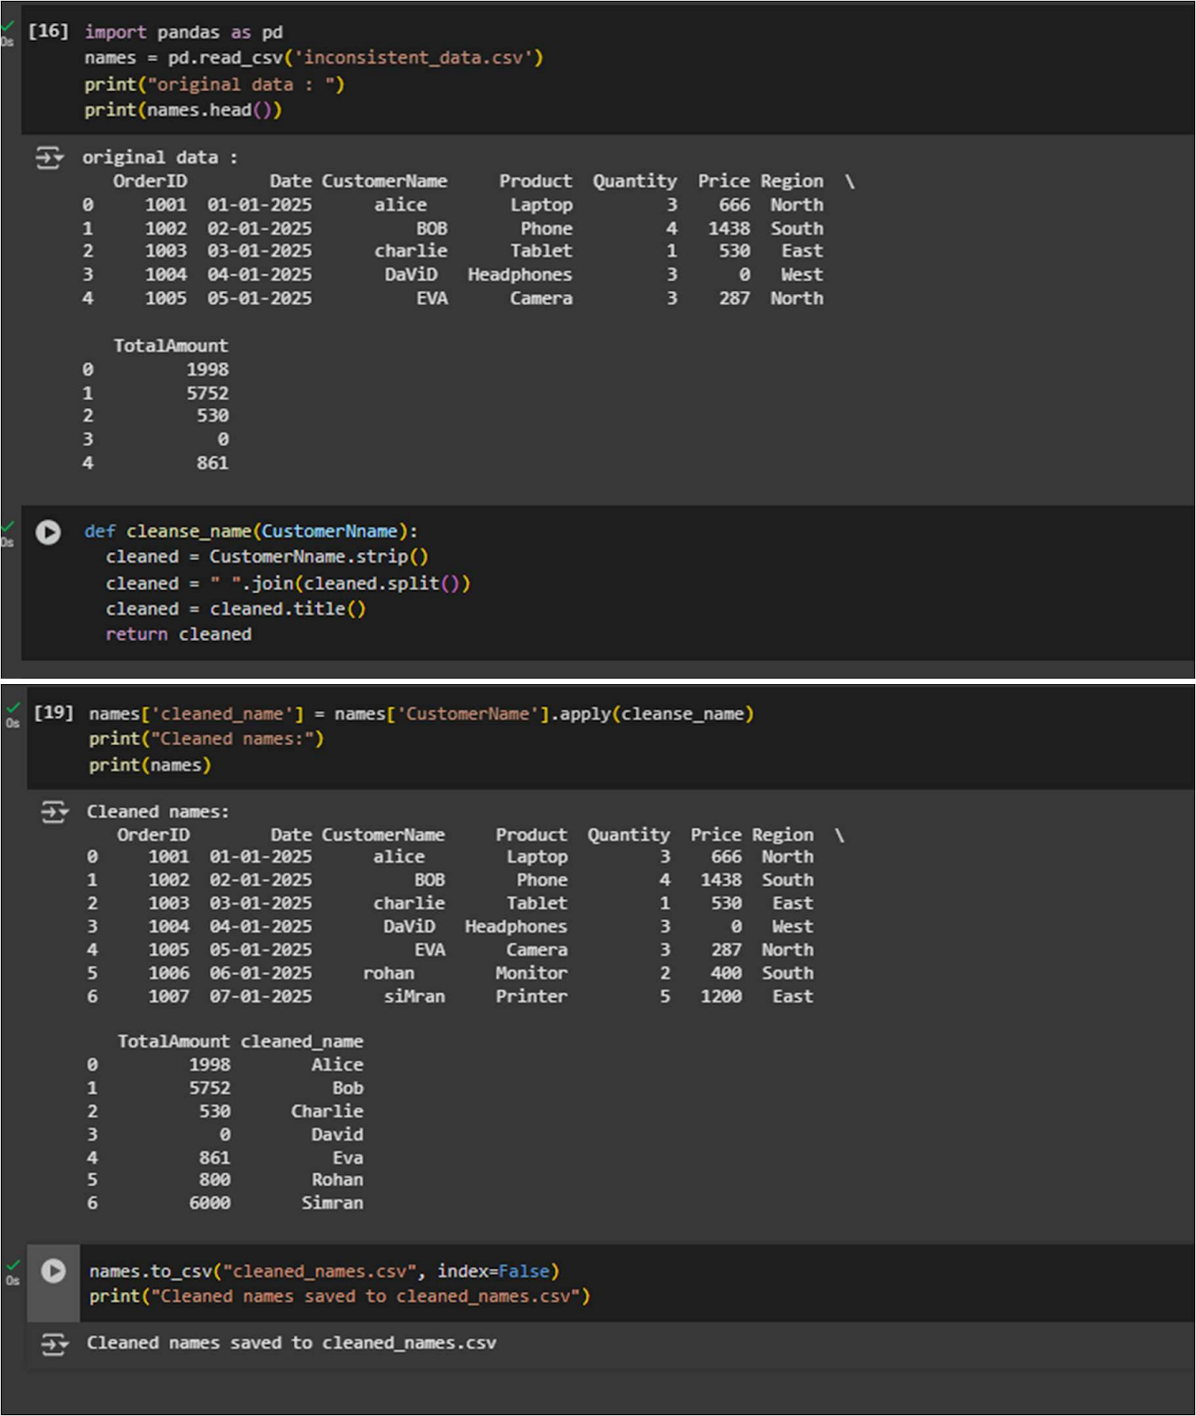

**Output:**

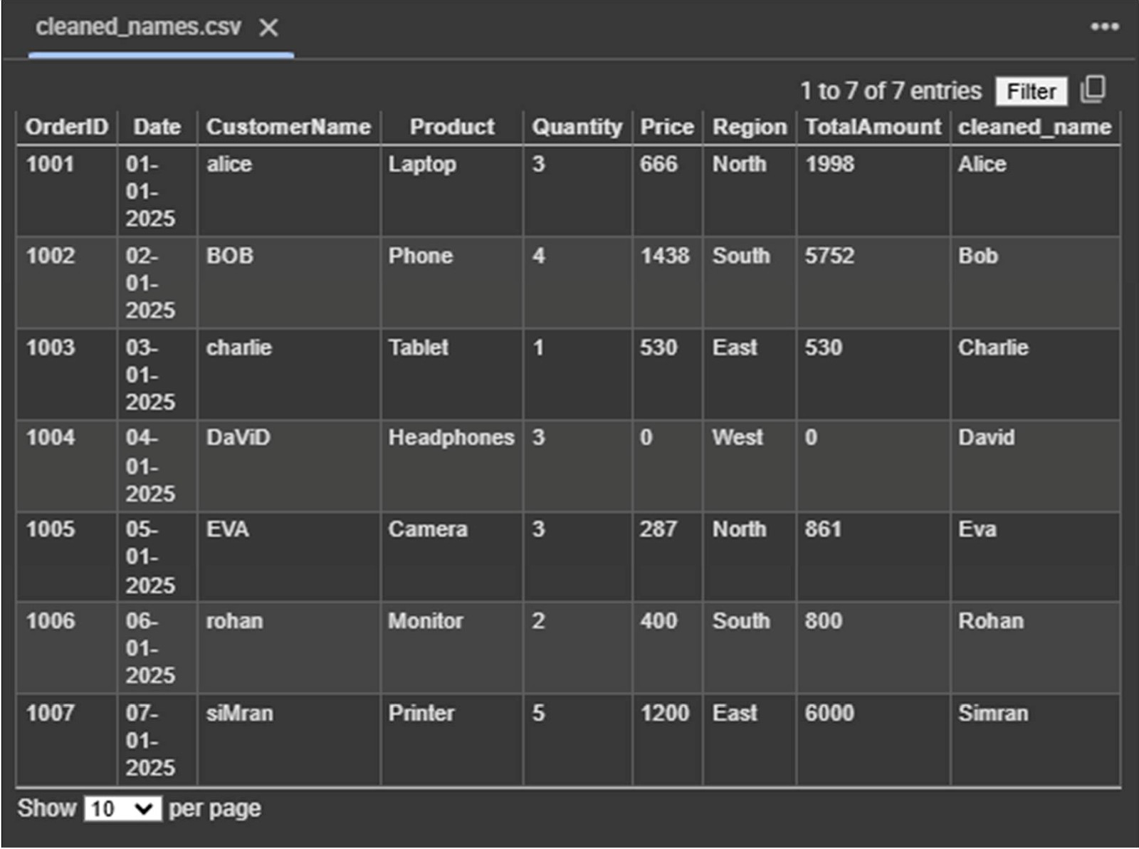

**Learning Outcomes:**

## EXPERIMENT 3

**Aim:**  Program of Data warehouse cleansing to remove redundancy in data.

**Theory:**

**Dataset:**

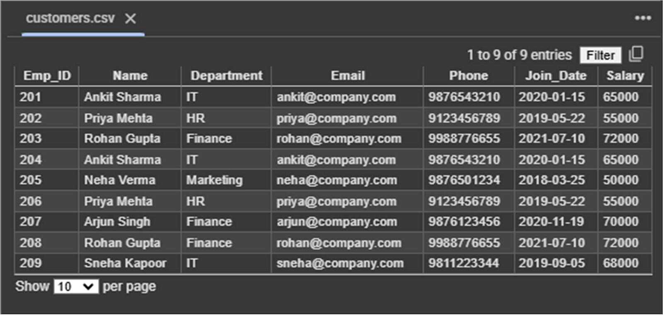

**Program:**

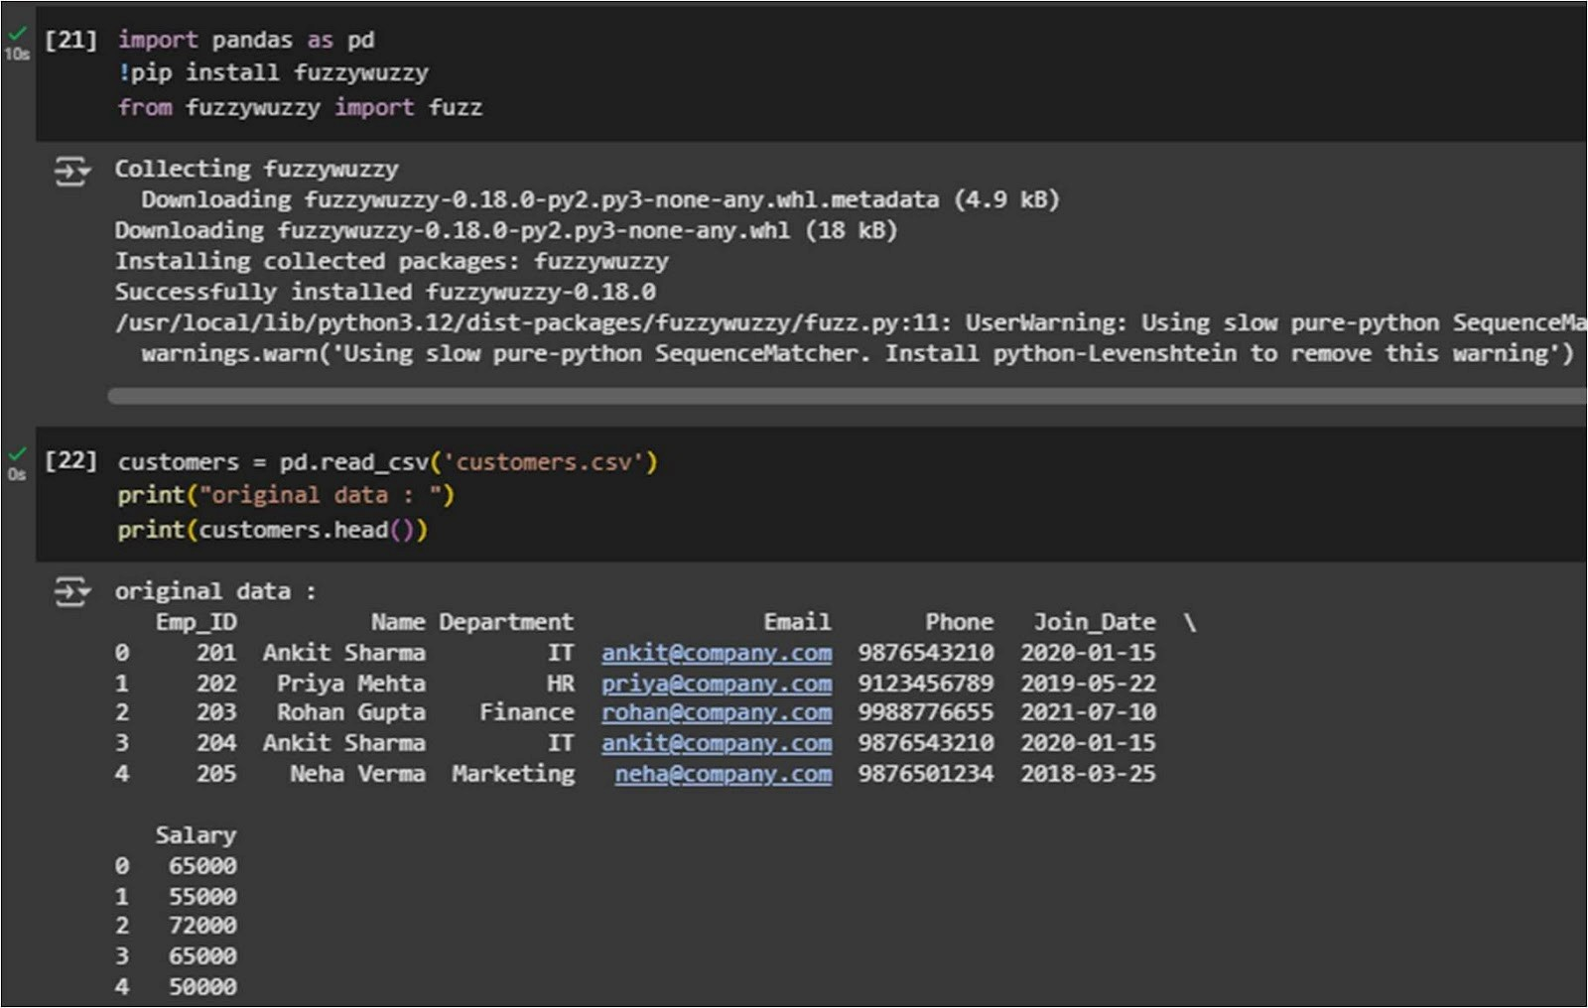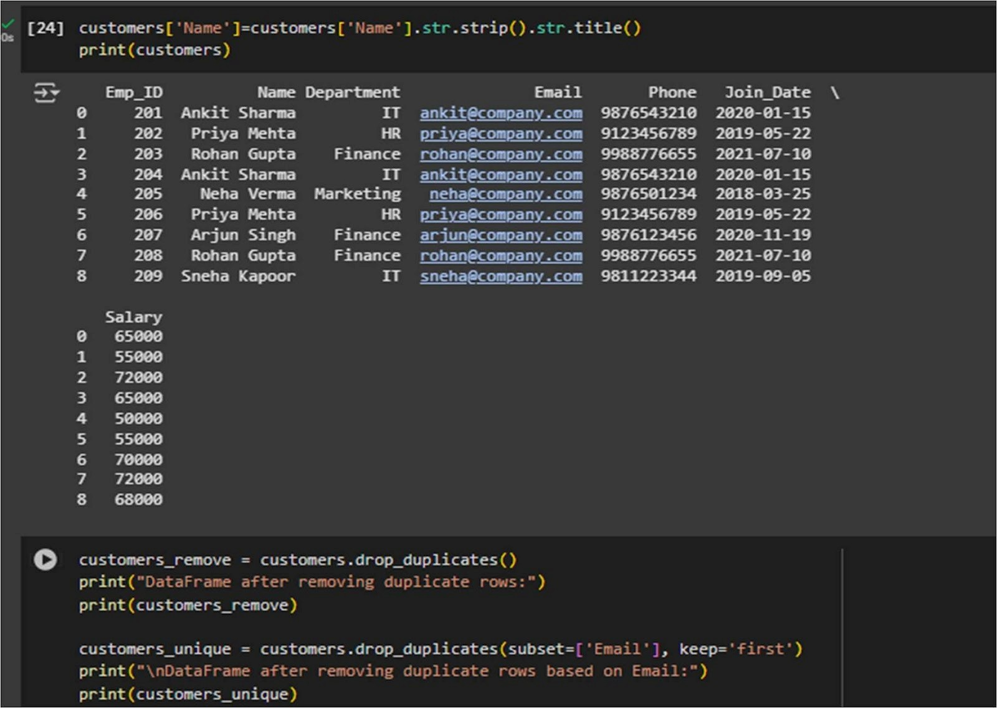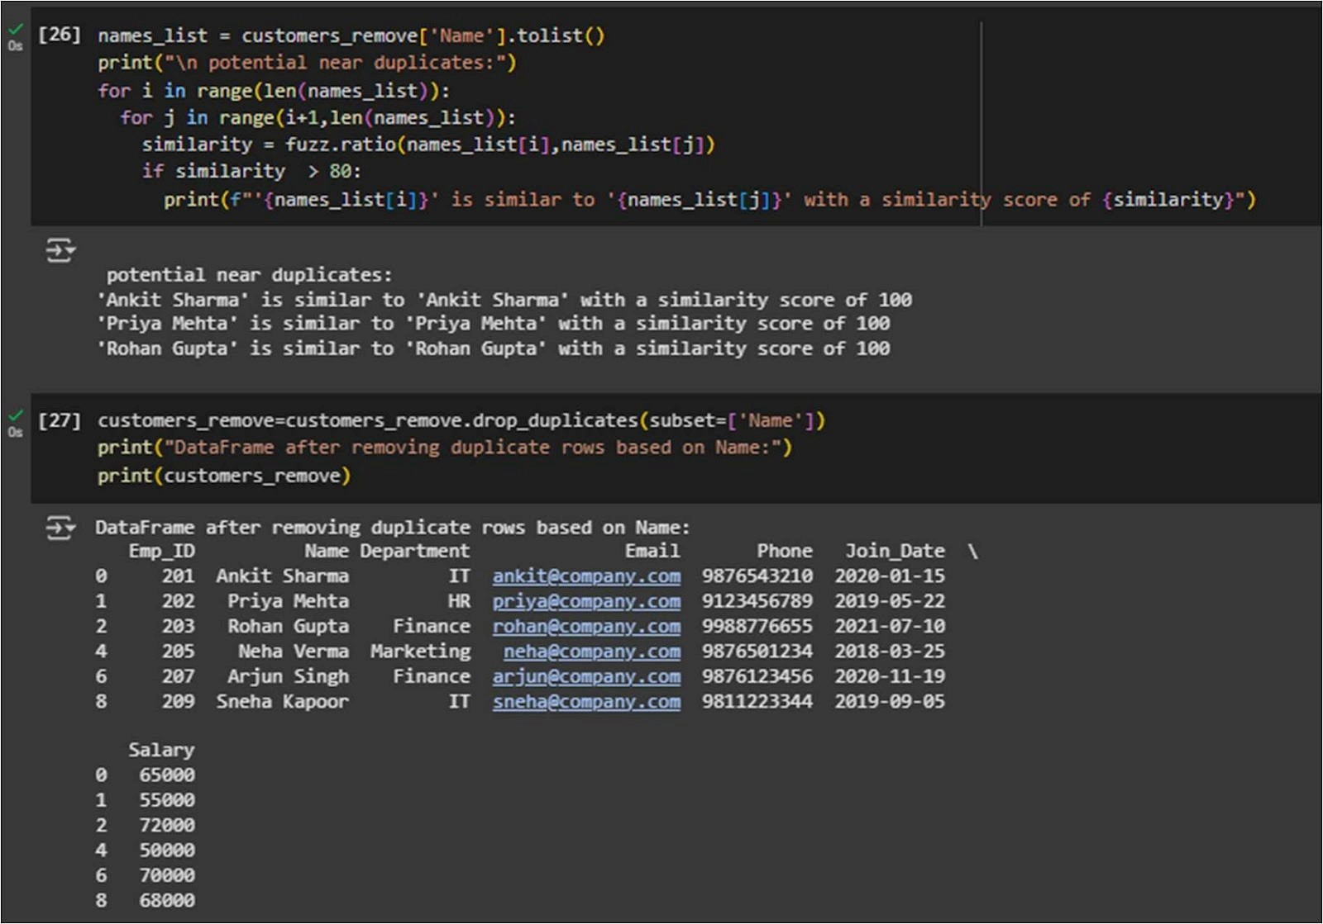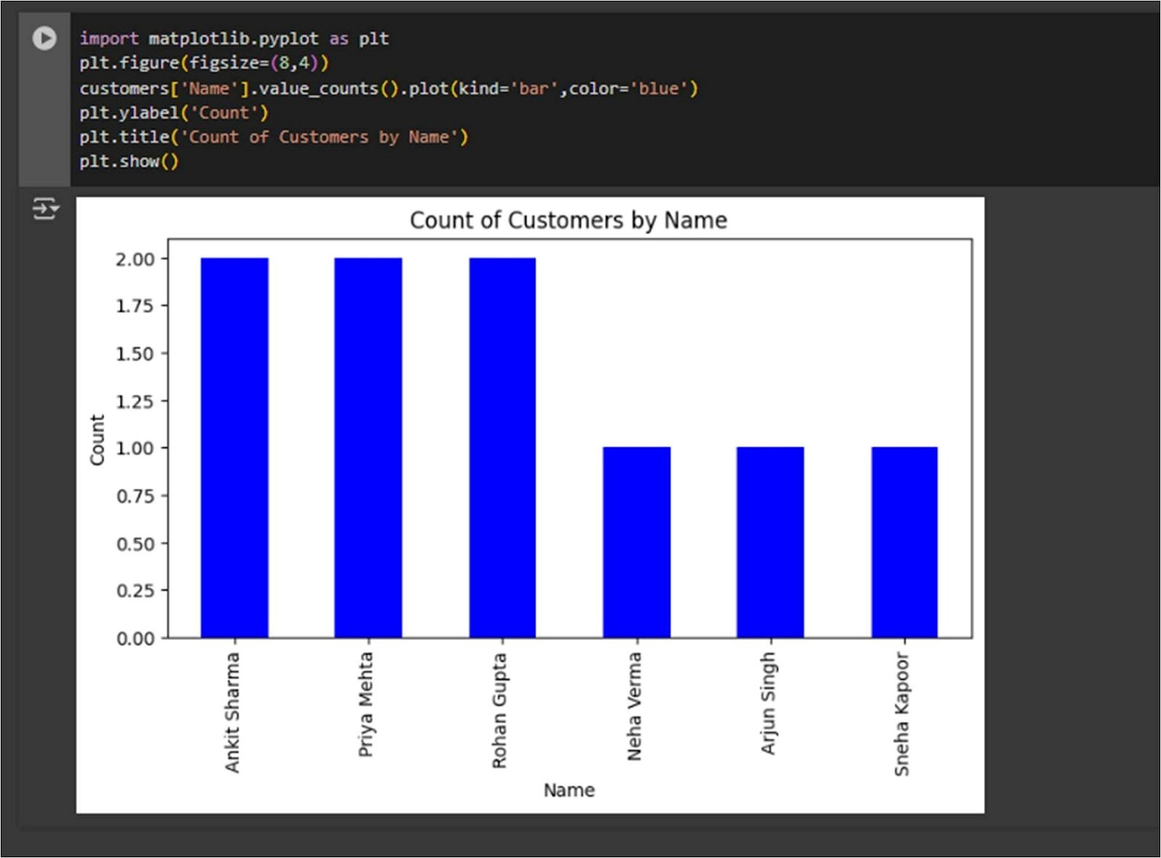

**Output:**

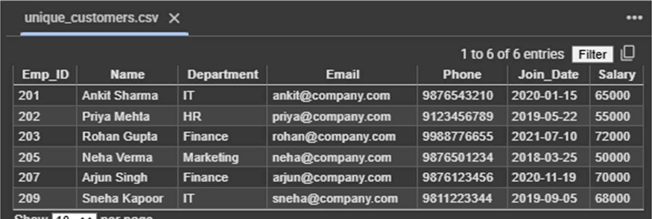

**Learning Outcomes:**

## EXPERIMENT 4

**AIM:**  Introduction to WEKA tool.

**THEORY:**

**WEKA:**

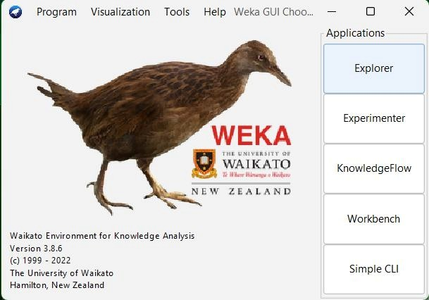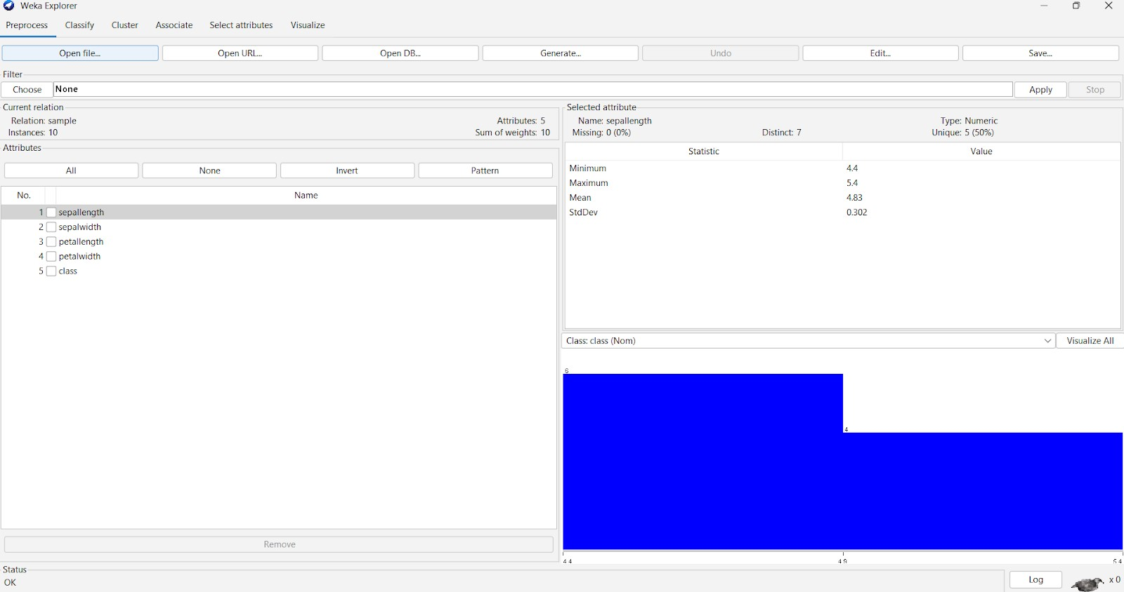

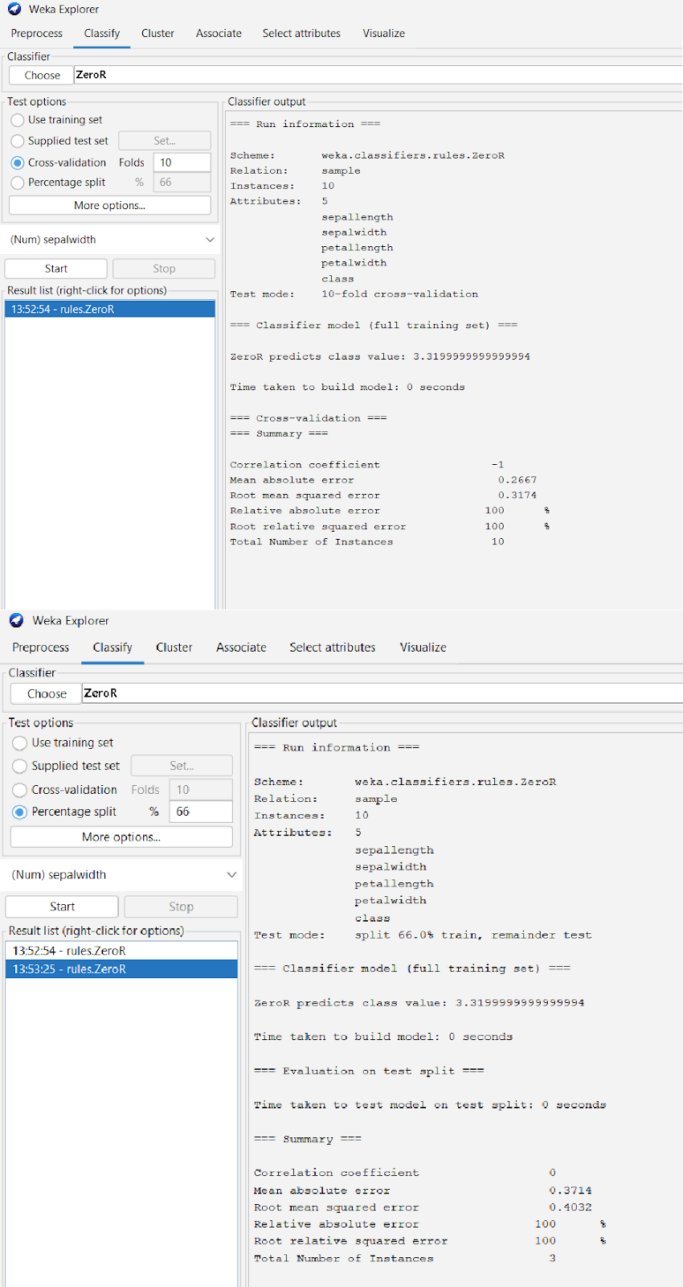

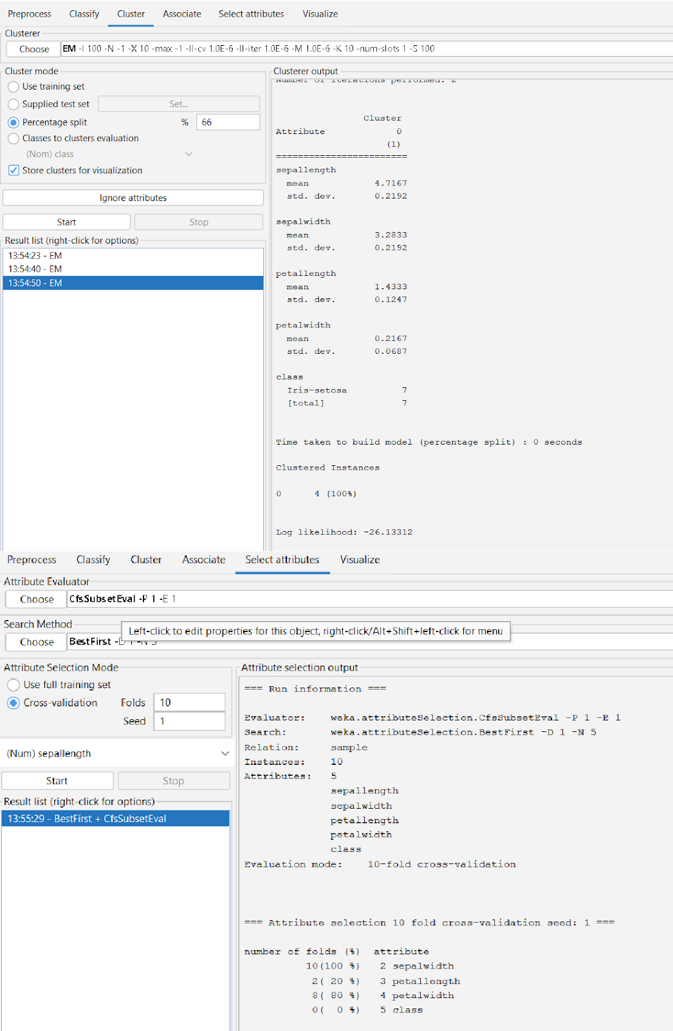

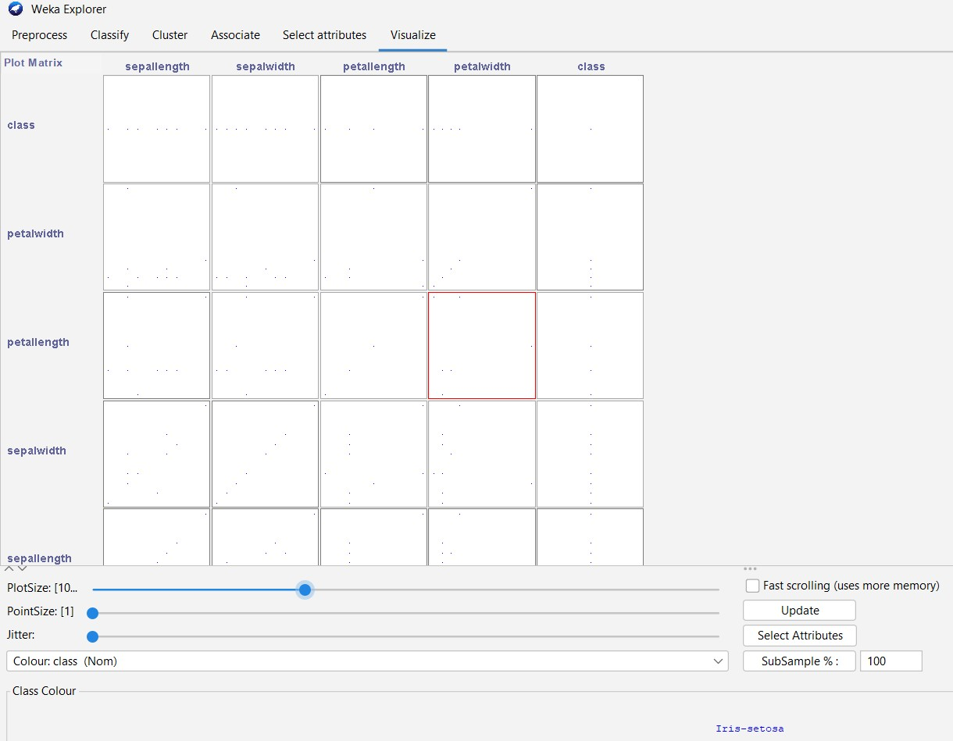

**Learning Outcomes:**

**EXPERIMENT 5**

**Aim:** Implementation of Classification technique on ARFF files using WEKA.

**Theory:**

**Dataset:**

**WEKA:**

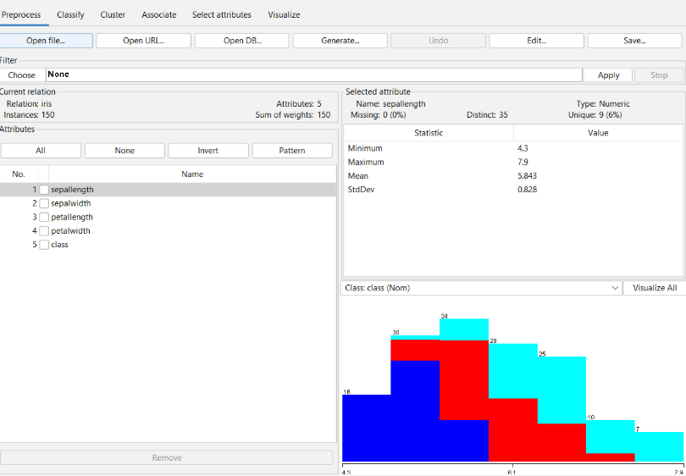

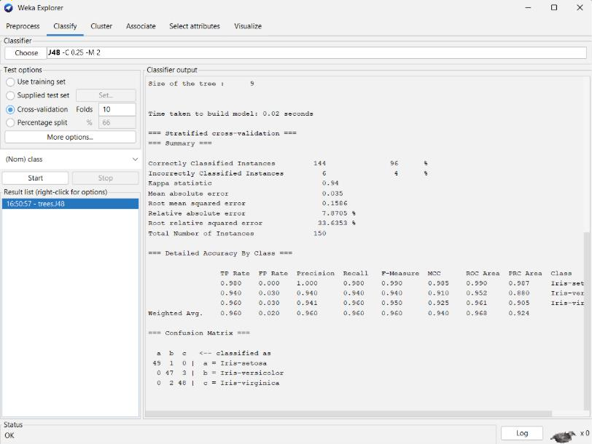

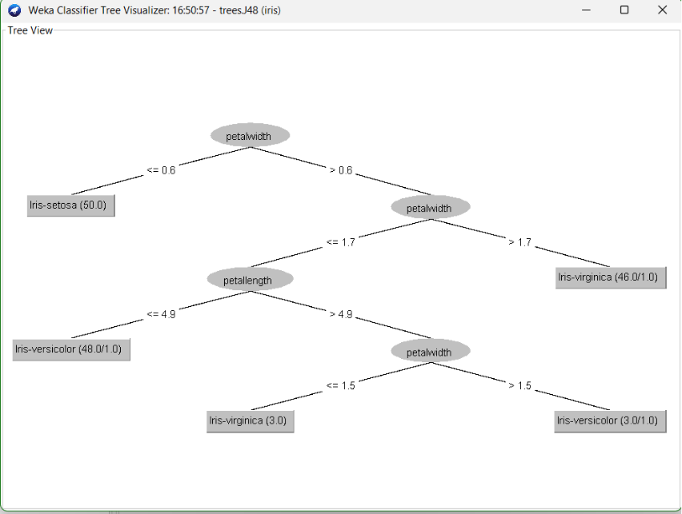

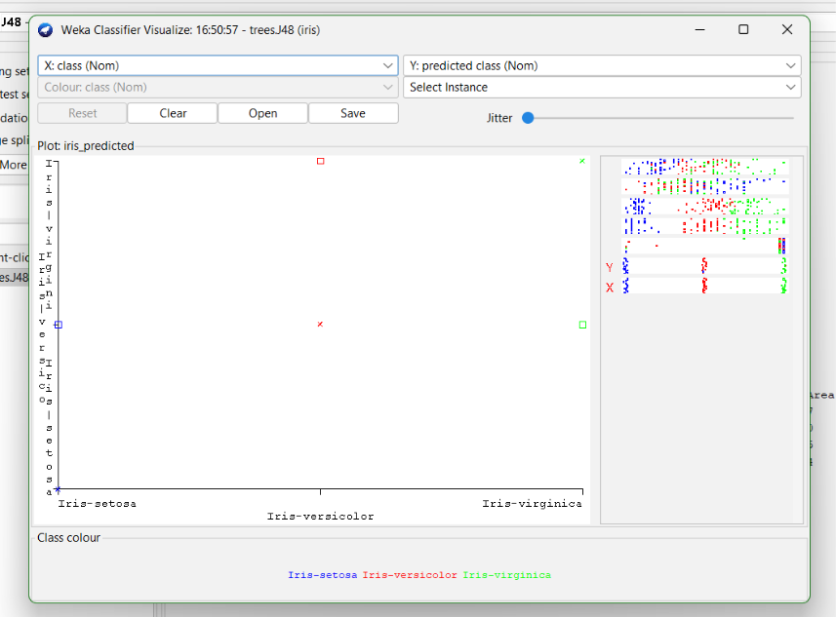

**Learning Outcomes:**

**EXPERIMENT 6**

**Aim:** Implementation of Clustering technique on ARFF files using WEKA.

**Theory:**

**Dataset:**

**WEKA:**



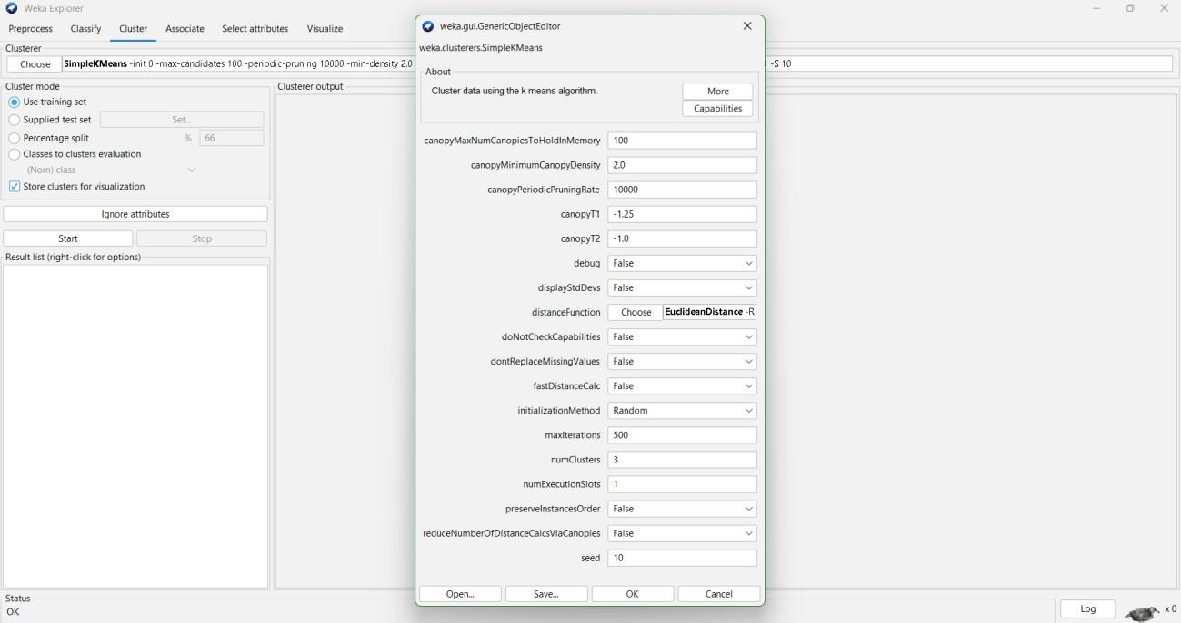

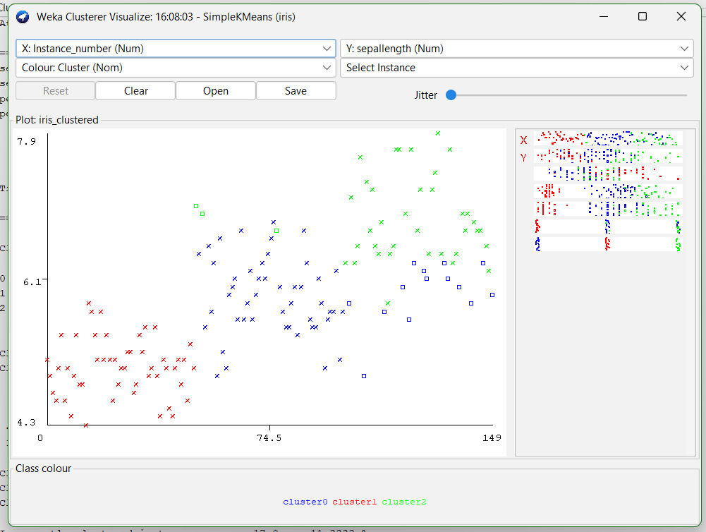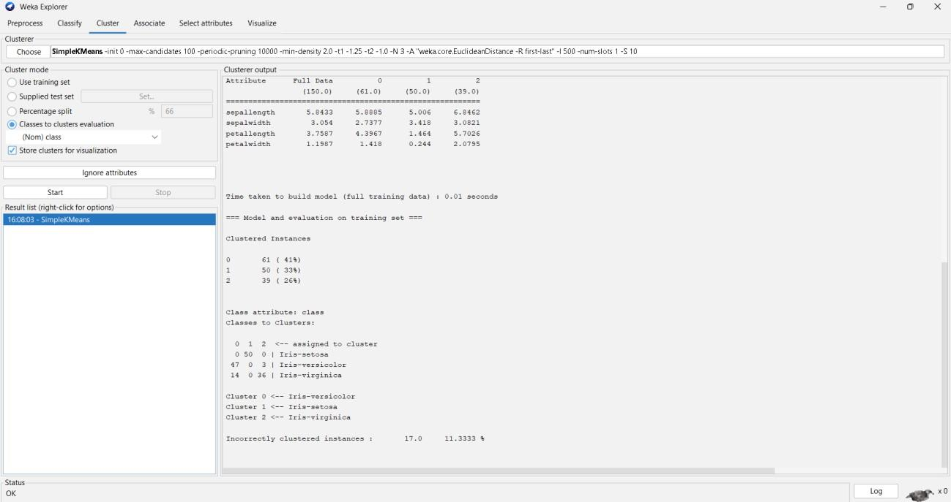

**Learning Outcomes:**

**EXPERIMENT 7**

**Aim:** Implementation of Association Rule technique on ARFF files using WEKA.

**Theory:**

**Dataset:**

**WEKA:**

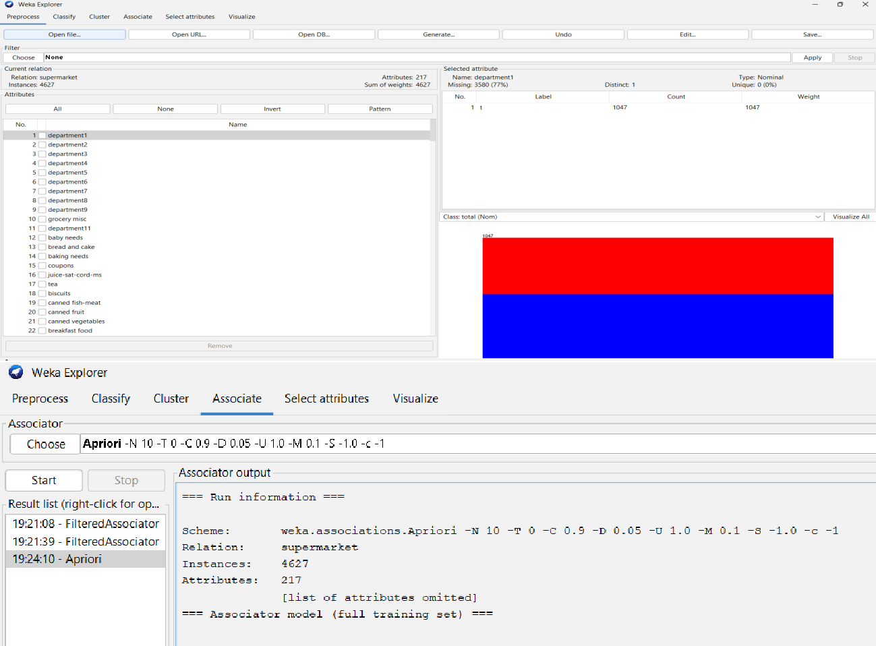

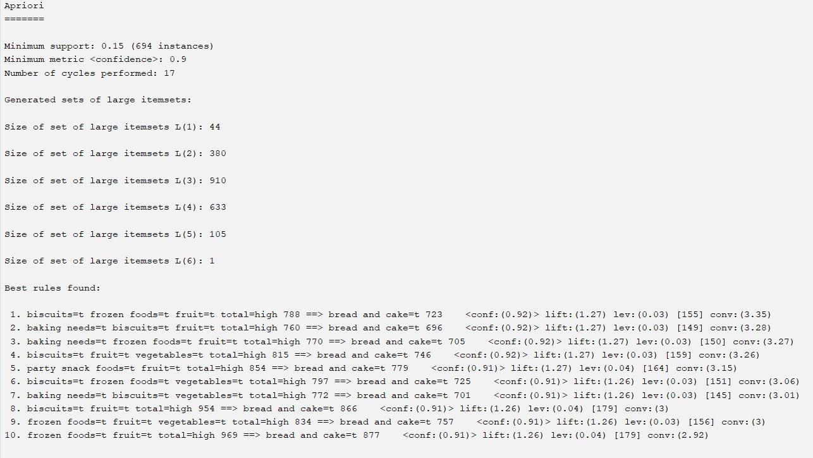

**Learning Outcomes:**

**EXPERIMENT 8**

**Aim:** Implementation of Visualization technique on ARFF files using WEKA.

**Theory:**

**Dataset:**

**WEKA:**

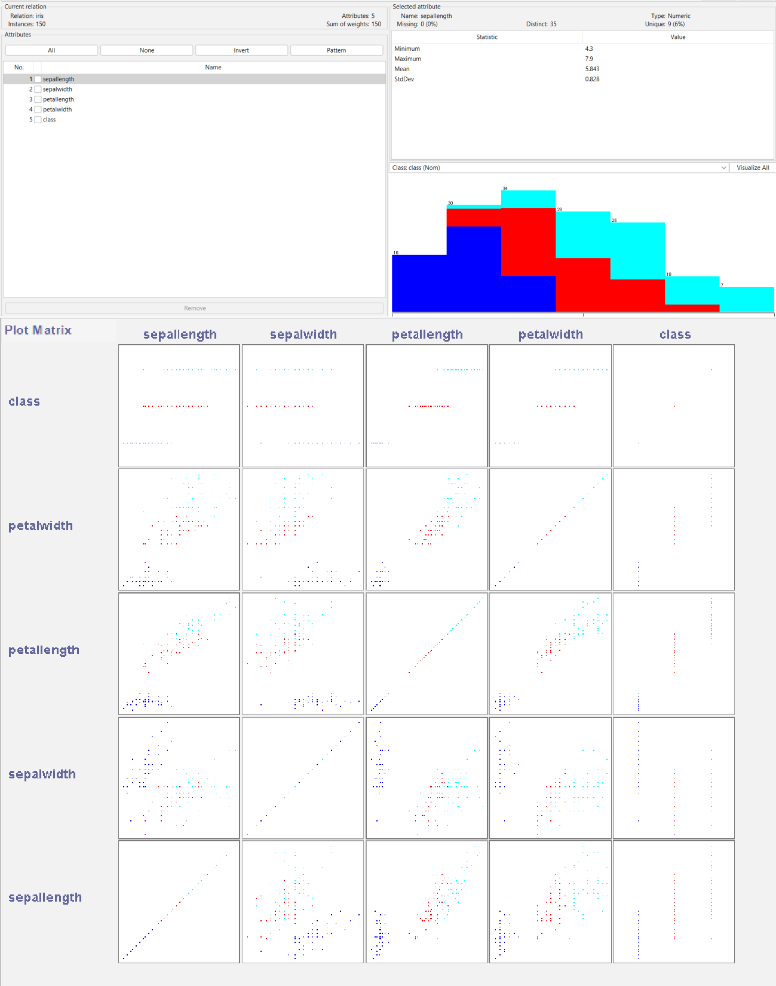

**Learning Outcomes:**